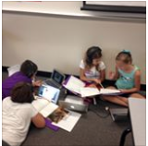****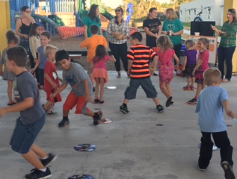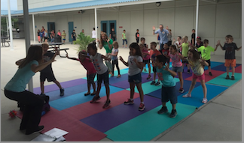

We are asking for your commitment in making sure your child attends school every day possible this year. Evidence shows children with good attendance are more likely to be successful in school. This begins in Kindergarten. Everyday Counts!! Students with good attendance perform better in math and reading.

We are asking for your support in helping your child get to school on time every day this year. Your child needs to be engaged in learning to reach his or her full potential. We realize that every family faces challenges: illness, transportation, and scheduling demands. We will do our best to help each family ensure that each child’s attendance stays on track.

Students come on campus: 9:15

Student Breakfast: 9:20

Student Go to Class: 9:30

Students are Tardy: 9:45

Transportation Changes Stop: 3:15

Student Dismissal Begins: 3:40

### Attendance

# The 1st quarter is already behind us and we have moved into quarter 2 of learning. We have a number of new students that have join us this year and have become one of our Sea Stars. Our old and new Sea Stars are working hard every day to demonstrate what they have learned and understand through projects and activities.

# Please remember to stay involved in your child’s education by communicating with the teachers. The agenda book and our Tuesday News Day folders are two great ways to keep information going between home and school.

# As always we thank you for your support and welcome suggestions. In order to shine with excellence all the STARS must work together.

# 

# Ms. Schooler & Ms. Iarussi

October 29

November 19

6:00 – 7:30

Family Learning, Homework & Dinner

October 27

November 10

December 1, 15

January 5

5:30 – 8:00

Fun & Food

PTO Food Drive 11/11-12

Great Am. Teach In 11/18

Thanksgiving Break 11/23-27

STEM Workshop 12/3

PTO Holiday House 12/7-11

Winter Wonderland 12/8

PTO Parent Night Out 12/11

Winter Break 12/21-1/4

Teacher Planning 1/15

##### **Other**

##### **McStar Nights**

##### **FOCUS Diners**

#### Special Dates

Gulf Trace Elementary

Hope Schooler, Principal Trish Iarussi, Assistant Principal

The SURFER

Fall, 2015

We have partnered with the Sheriff’s Department to be visible on our campus and to build relationships with many of our students. By being on our campus and interacting with our students we feel that they will be able to also have positive interactions when in the community with our students and families.

**Partnership**

**Thank Yous……**

Without our Business Partners we could not do some of the special things we do for our students. A BIG Thank You to each of them for all of their help!!

Horace Mann Sun Toyota SAMS,

Metropolitan Ministries Holiday Rec Center

Wal-Mart McDonalds

We hope that many of you are taking time to do some type of physical activity that is on their monthly calendar with them. Our focus is Healthy Minds, Healthy Bodies!!!

**Healthy Activity Calendar**

**Volunteers**

## **STAR Reading**

# **Student Clubs**

###### We have Chorus, Recorder, and Sports Clubs that began earlier this month. More of the 2015-16 Student Clubs will begin in November. Some of our students will have some exciting opportunities to be involved in school activities and having fun outside of their classrooms.

Our students earn steps each day for every 15 minutes that they read. Classes spend 30 minutes daily reading so they earn two steps at each day at school. We encourage our students to read another 30 minutes at home each night. Students reading 100 steps by designated dates are rewarded with token to add to their dog tag chain.

We are always looking for classroom volunteers, Watch D.O.G.S., and assistance with All Pro Dads, and iMoms. **Step 1** is completing an application on the Pasco website. **Step 2** get in touch with Denisha Sanchez (246-3602) who will direct you to the appropriate person to get you started.

**STAY CONNECTED!!!! Follow us on…**

School website: <http://gtes.pasco.k12.fl.us>

Facebook page: facebook.com/GulfTraceElementary

Twitter: twitter.com/GTESSeaStars