Name: ________________________________

Video and Abstract Outline
Put the pieces of your work together. In the table below, pull your thinking into one place. The questions below are meant to help you build an outline of what you plan to share in your video and what to write in your abstract. This is really just a place to organize your thinking.

What is the problem you are trying to solve?
Why did you select this problem?
Detail about the problem
Detail about the problem
Detail about the problem
Describe your innovative solution
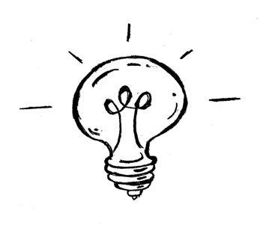

Create a Prototype

This is not a mandatory part of the project. You want to be sure that you can describe your solution in detail in your video. One way to help you share your solution may be to use a model in your video. A model can be something your draw and label, a sample you build of your larger solution, an animation, a graph or table. Models are anything that helps us educate and share our thinking with others.

Think about when you learn a new math strategy or a new science idea, what helps you to understand the new idea? Think about how you can help the audience understand the solution you share on video.

