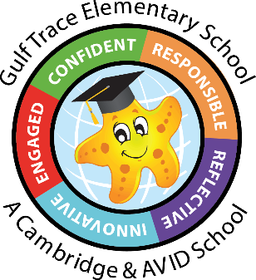Gulf Trace Elementary School

1st Grade Supply List

24-25

(12) glue sticks

(2 boxes) 24 count Crayola crayons

(1) pair of scissors

(24) #2 pencils, pre sharpened

(6) large pink erasers

(4 packs) Expo markers (black)

(2) highlighters

(1) Composition notebooks (Wide ruled)

(1) pair of over ear headphones (MANDATORY)

(4) packs of copy paper

(4) boxes of tissues

(1) large bottle of hand sanitizer

Boys 1 box of Ziploc gallon size bags

Girls 1 box of Ziplock quart size bags

(1) box of Ziplock snack bags

(3) package of Clorox/Lysol wipes

\*You do not need to write your child’s name on any of the supplies.

Wish list items (if you want to donate, not required):

* Extra headphones for student in need

