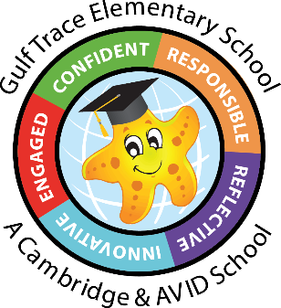Gulf Trace Elementary School

Kindergarten Supply List

24-25

* 12 glue sticks
* 2-24 box of Crayola crayons
* 1 pair of scissors
* 1 box of tissues
* 2 **primary** composition notebooks (white space on top for picture and lines on the bottom to write)
* 1 box of Magic Erasers
* 2 refill packages of baby wipes
* 2 containers of Clorox wipes
* 2 yellow highlighters
* 1 pencil pouch
* 6 Expo markers (black)
* Ziploc bags- Boys: 1 box of sandwich-sized bags

Girls: 1 box of gallon-sized bags

* Headphones (not earbuds) with your child’s name on them

In a gallon-sized bag, please provide one change of clothes as accidents happen. Place your child’s name on the bag.

