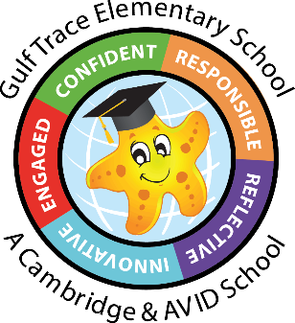Gulf Trace Elementary School

2nd Grade Supply List

24-25

(3) glue sticks

(2 boxes) 24 count Crayola crayons

(1) pair of scissors-**pointed**

(24) #2 pencils, pre sharpened if possible

(2) thin Expo markers

(1) pack of colored pencils

(1) pack of thick Crayola markers

(4) Composition notebooks (Wide ruled). No spirals please.

(1) plastic green folder with prongs and pockets

(1) pair of headphones or earbuds

(2) packs of copy paper

(6) boxes of tissues

(1) large bottle of hand sanitizer

(1) box of Ziploc sandwich or gallon size bags

(1) package of Clorox/Lysol wipes or baby wipes

*You do not need to write your child’s name on any of the supplies.

Wish list items (if you want to donate, not required):

* Extra headphones or earbuds for student in need
* Ziploc quart size bags
* Ziploc snack size bags

